CUSTOMER SHOPPING BEHAVIOUR PROJECT REPORT Project Overview-
Customer shopping behaviour analysis helps businesses deeply understand how customers interact with products, pricing, promotions, and channels before making a purchase decision. This project focuses on identifying key patterns in consumer actions such as purchasing preferences, frequency of purchases, product categories in demand, seasonal shopping trends, responses to discounts and promotions, and demographic influences on buying decisions. Studying this behaviour enables companies to improve sales forecasting, develop targeted marketing strategies, personalize customer experience, optimize inventory, and enhance customer satisfaction.

Objective and purpose-
The main objective of this project is to analyze real customer purchase data to uncover meaningful insights that support strategic decision-making. Through analytical tools like Power BI, SQL, and Excel, the project aims to identify what customers buy, how often they buy
how much they spend, and the factors that influence their purchase decisions.

Problem Statement-
Many retail businesses struggle to understand consumer buying trends due to unorganized data and lack of analytical direction, resulting in poor marketing decisions, high inventory costs, and low customer retention. This project aims to solve this issue by analyzing structured customer data and presenting insights in a simplified, visual format.

Importance and Relevance-
Understanding customer behaviour is essential for businesses to stay competitive. This analysis provides valuable findings that can help improve marketing effectiveness, increase revenue, and boost customer loyalty.

Tools & Technologies Used-

# Microsoft Excel – Data Cleaning
Used for data preparation including removing duplicates, handling missing values, formatting corrections, and organizing data using functions like VLOOKUP, FILTER, and Pivot Tables.

# SQL – Data Analysis & Insights
Used to extract meaningful insights from the dataset through queries such as GROUP BY, WHERE filtering and aggregate functions (SUM, COUNT, AVG) to understand purchase patterns and customer segmentation.

#Power BI – Dashboard & Visualization
Used to create interactive dashboards with charts, slicers, KPIs, and DAX measures to visually represent trends, spending behaviour, and customer demographics for business decision-making.

DATA ANALYSIS USING SQL-
We performed structured analysis in PostgreSQL to answer key business
questions:

Total Sales by Items-
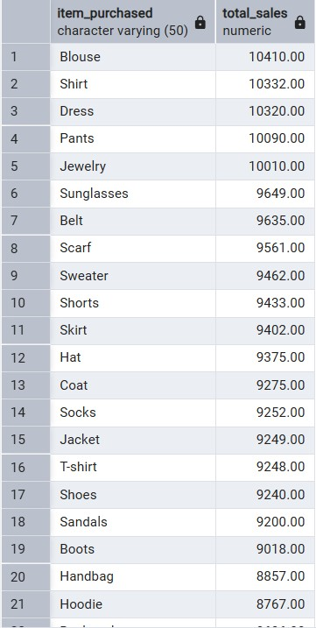

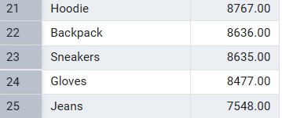

Total sales by category-
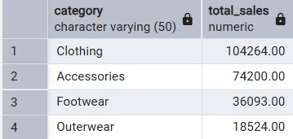

Total sales contribution by gender-
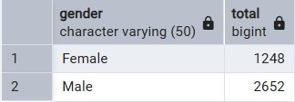

Total sales-
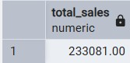

Top 5 highest-selling locations-
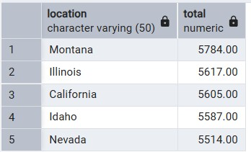

Sales according to product sizes-
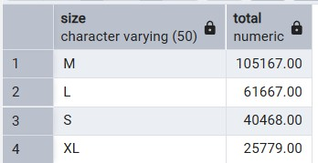

Top 5 products with the highest total sales, along with their color variants-
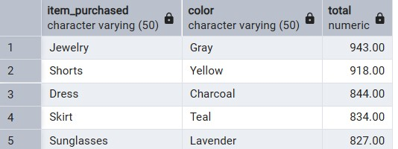

Identifies the highest and lowest amounts paid by customers in a single transaction-
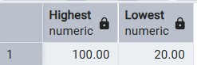

Summarizes total sales according to different seasons-
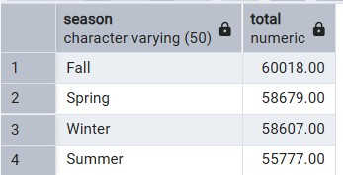

Customer review ratings to measure satisfaction and product performance-
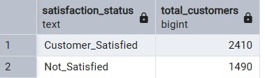

Subscription status of customers, distinguishing between subscribed and non-subscribed users-
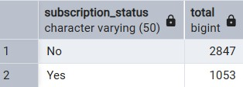

Identifies the most preferred shipping methods among customers-
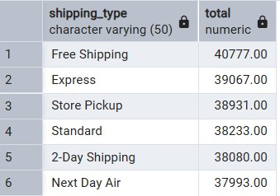

Discount applied by customers-
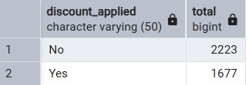

The most frequently used payment methods among customers-
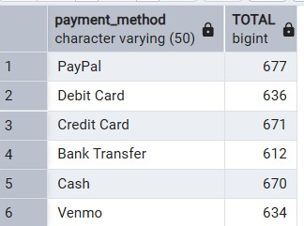

This analysis examines how often customers make purchases-
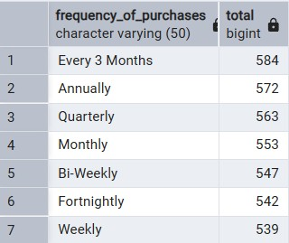

This analysis segments customers into defined age groups to understand purchasing behavior across different age ranges-
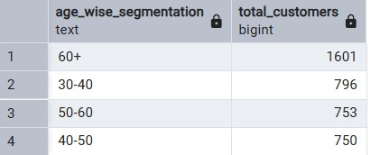

DASHBOARD IN POWER BI-
Developed an interactive Power BI dashboard to analyze retail sales and customer behavior. Key analyses included total sales, top-selling products and colors, sales by location, season, and size, as well as customer segmentation by age, gender, subscription, and purchase frequency. Visualizations such as bar charts, pie charts, and KPIs provide actionable insights into revenue trends, customer preferences, and operational performance. DAX measures and Power Query transformations were used to create meaningful metrics and enable dynamic exploration of data.

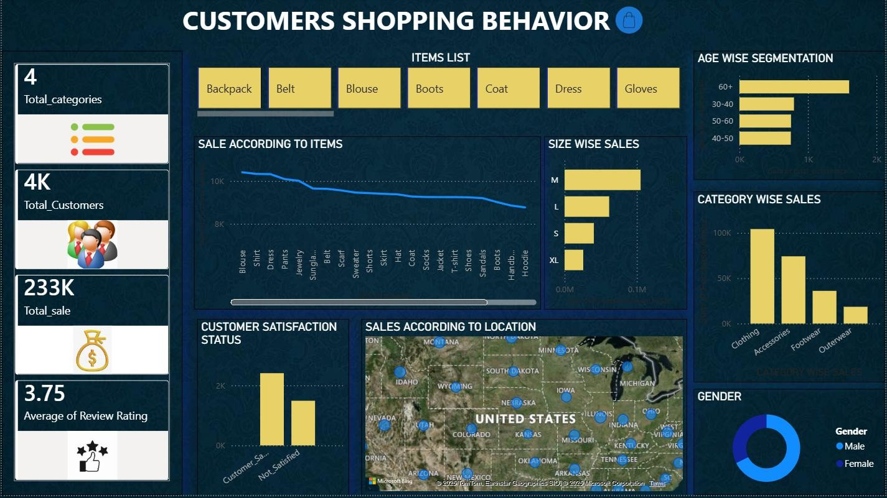

BUSINESS RECOMMENDATIONS-
- The lowest-selling category is Outerwear; the company should focus on improving sales in this segment.
- Align Outerwear production with customer preferences, market trends, and seasonal demand to increase appeal.
- Analyze customer behavior, purchase patterns, and marketing conditions to design products that match customer tastes. Prioritize development and promotion of male-targeted products, as double the consumers are men, to maximize revenue and market share.

